MAGNUM ENGINEERING
PARK FARM

COMPTON VERNEY
WARWICK

CV35 9HJ

TEL/FAX: 01926 642122

www.magnum-engineering.com
e-mail: m.broad@magnum-engineering.com

ROVER V-8 CONVERSIONS

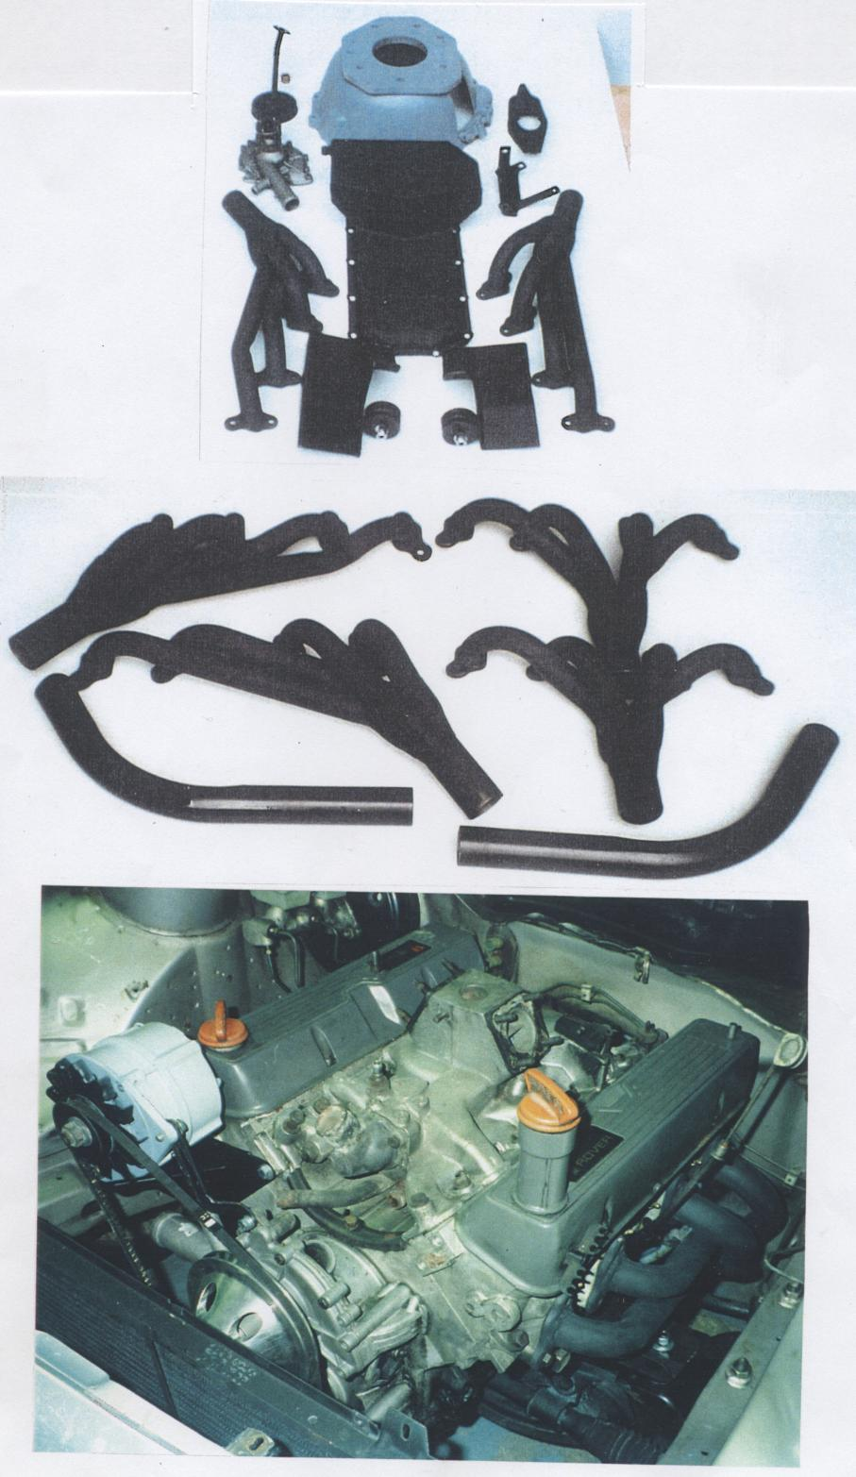

FORD SIERRA 1.6/2.0/2.8
CONVERSION PARTS LIST FOR ROVER V-8 CONVERSION

Engine Mounts pr. Inc. rubber mounts 75.00

Sump. Exchange. Modified to clear crossmember 85.00

Oil Pick-up pipe. Large bore to match sump 25.00

Gearbox adaptor/bellhousing for 2.3/2/8 5 spd. 175.00

Gearbox adaptor/bellhousing for Cosworth T5 box 195.00

Release arm (for cable clutch) 25.00

Release bearing 15.00

Pilot bush. Fits rear of crank 10.00

Exhaust manifolds pr. Tubular, short style
Rear outlet 4 into 1. 2⅛” collector dia. 175.00

Down pipes 2” OD pr. 25.00

Spacer kit (to give anti-roll bar clearance) 25.00

Short water pump. New. Not recon. 55.00

Pump pulley for above 28.50

Crank pulley. Machined to match short pump
(exchange) 27.50

Flex fan. St.Steel. Mechanical cooling fan 29.95

Alt. Bracket 25.00

All parts available separately. All prices plus carriage and VAT. Basic written instructions supplied with all parts. We accept credit card/cash/cheque.
The following components allow the use of the Rover SD1 5 spd. Gearbox although some transmission tunnel mods are required.

Hydraulic clutch conversion kit. Includes exchange
Pedal box which mounts a special clutch master
Cylinder. This kit includes master cylinder, remote
Fluid reservoir for positioning inside engine bay and
All relevant pipework. £100.00

Gearshift remote. Exchange gearshift remote,
positions gear lever 6” further forward and
improves shift quality. £75.00

Ford Capri – Rover V-8 Engine Components

Engine Mounts per pr. Inc. rubber mnts (no welding) 75.00 pr

Sump. Exchange only. Clears crossmember 85.00

Oil pipe. Matches modified sump 25.00

Gearbox bellhousing/adaptor for Ford 2.8/5spd 175.00

Gearbox bellhousing/adaptor for Cos T5/5spd 195.00

Gearbox bellhousing/adaptor for 3litre/4spd 175.00

Clutch release arm (takes standard clutch cable) 25.00

Crankshaft pilot bush 10.00

Exhaust manifolds per pr. 4 into 1 rear outlet
Short style with 2⅛” OD collector pipe dia. 175.00

Down pipes. 2” OD. Takes manifolds down under
Car to plumb into standard V-6 system 25.00 pr

Short water pump. New, not recon. 55.00

Crank pulley. (SDI type) Machined to match pump 30.00

Flex fan. St.Steel mechanical hi-flo fan 29.95

Alternator bracket 25.00

All parts available separately. All prices plus carriage and VAT
We accept credit card/cheque/cash payment with order

ROVER V-8 CONVERSIONS

ADDITIONAL COMPONENTS AVAILABLE

Engine Mounts: We produce the following mounts for:

Ford Capri 1.6/2.0/2.8,3.0 )
Sierra )
Cortina Mk.III,IV & V ) All £75.00 pr
Granada ) inc rubber mounts
Transit ) + VAT

The 2.8/3.0 litre Capri mounts are probably the nearest to fit the 100E. They take a heavy duty version of the normal round biscuit type rubber mount which has a 10mm dia stud from each side.

DIY gearbox crossmember kits available for:

Rover SDI box )
Ford 2.8/5spd ) £25.00 ea + VAT
Ford 3.0/4spd ) includes rubber mount
Cosworth T5/5spd )

Exhaust “Y” piece available @ 2” OD left, right hand or central. £35.00 ea.

New:

Rover V-8 Rocker Cover Adaptors. Allows the use of Chevrolet rocker
covers on the Rover V-8 engine. The laser cut steel adaptors are thick
enough to be fitted to the heads without a gasket and just a smear of
silicon sealer. However, long enough screws are supplied if a gasket
is preferred! Adaptors are complete with screws to hold them on to
Rover cyl. Heads, studs and nuts to hold down the Chevrolet Rocker
Covers. £50.00 pr.

Rover Rocker Cover Gaskets £3.50 pr.
Chevrolet Rocker Cover Gaskets £3.00 pr.
Mr Gasket Chrome ‘T’ bolts
(inc. studs to enable them to be used as male or female attachment).
Set of 4. £10.00 set

NB: There is a large choice of Chevrolet rocker covers with or
Without any logo on them ranging from chrome, gold or blue
Anodised to elaborate cast alloy inc. Cobra script or period
1950’s style. Please enquire for further details. Prices start at £40.00 pr.

